Nicholas Harris

40111093

Assignment 3 – COEN352

1. An array that is sorted in decreasing order is a max-heap. Each children node will be smaller than the parent node and will be stored at index 2k+1 and 2k+2 for the left and right respectively, where k is the index of the parent node. This leads to a continuous structure that reads from left to right on the tree, like an array sorted in decreasing order.

For example, array: 9 8 7 6 5 4 2 1 will be the tree:

9

8 7

6 5 4 2

1

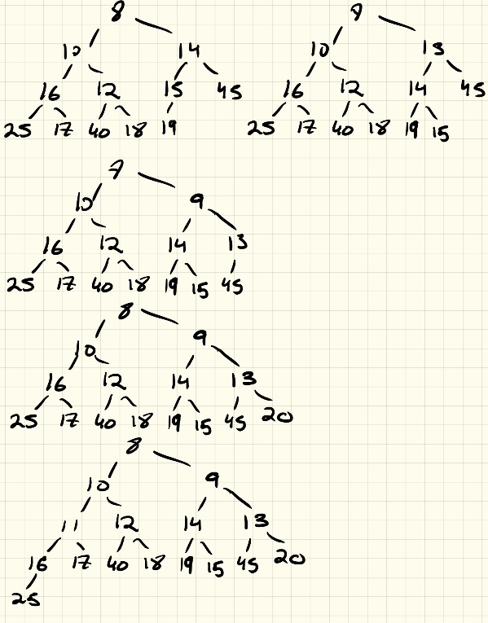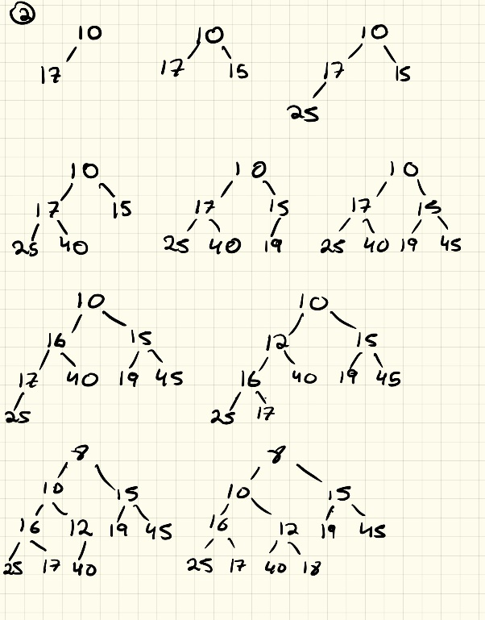

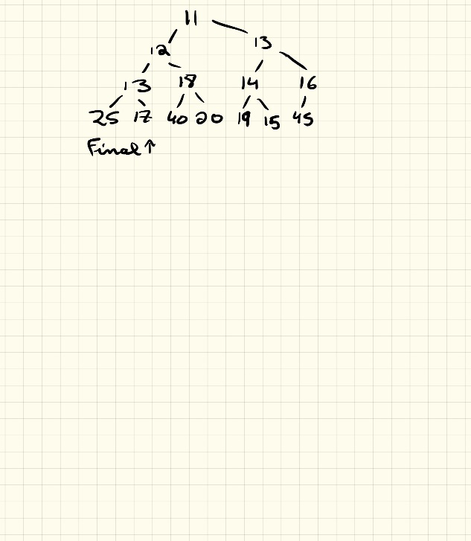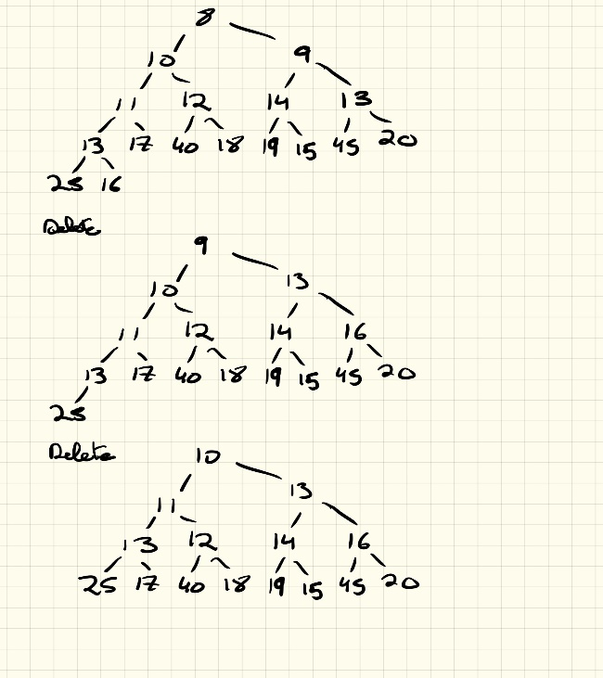

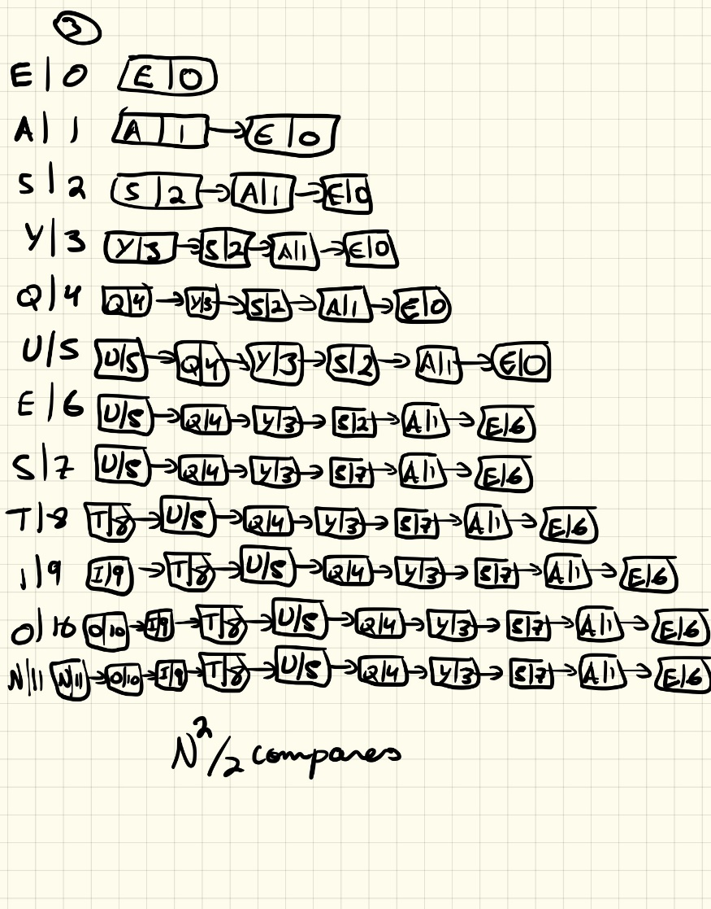

1. Best case tree would be:

H

E R

A C S X

Ordering 1: HEACRSX

2: HEACRXS

3: HECARSX

4: HECARXS

5: HERASCX

1. a. E > Q? -> Move to right child node, Q == Q? True, Move Q to E.

b. Select item at rank 5, Select (5) = M

c.E > F? -> Move to right child node, Q == Q? True Node Q is ceiling of Q

d. Rank(J) = 3 + 1 = 4

e. Size(D) = 1 + 0 + 1 = 2, Size (T) = 1 + 0 + 1 = 2. Size(D, T) = (2,2)

f. Keys(D,T) = (D,T)

1. 